NAMED ENTITY RECOGNITION

Minor project report submitted in partial fulfillment of the requirement for the
degree of Bachelor of Technology
in
Computer Science and Engineering
By
Aanchal Thakur (181285)
Kartik Bohra (181289)
Anurag Sharma (181278)

Under the supervision of

Dr. Rakesh Kanji

Department of Computer Science & Engineering and Information Technology

Jaypee University of Information Technology Waknaghat,
173234, Himachal Pradesh, India

DECLARATION

I hereby declare that, this project has been done by me under the supervision of Dr. Rakesh Kanji (Assistant Professor (SG), Department of CSE) Jaypee University of Information Technology. I also declare that neither this project nor any part of this project has been submitted elsewhere for award of any degree or diploma.

Supervised by:
Supervisor Name:
Department of Computer Science & Engineering and Information Technology
Jaypee University of Information Technology

Submitted by:
Aanchal Thakur
(181285)
Kartik Bohra
(181289)
Anurag Sharma
(181278)
Computer Science & Engineering Department
Jaypee University of Information Technology

CERTIFICATE

This is to certify that the work which is being presented in the project report titled “Named Entity Recognition” in partial fulfillment of the requirements for the award of the degree of B.Tech in Computer Science And Engineering and submitted to the Department of Computer Science And Engineering, Jaypee University of Information Technology, Waknaghat is an authentic record of work carried out by Aanchal Thakur (181285), Kartik Bohra (181289), Anurag Sharma (181278) during the period from January 2021 to May 2021 under the supervision of Dr. Rakesh Kanji, Department of Computer Science and Engineering, Jaypee University of Information Technology, Waknaghat.



Aanchal Thakur (181285)
Kartik Bohra (181289)
Anurag Sharma (181278)

This is to certify that the above statement made by the candidate is true to the best of my
knowledge.

Supervisor Name: Dr. Rakesh Kanji
Designation: Assistant Professor (SG)
Department of Computer Science & Engineering and Information Technology
Jaypee University of Information Technology

ACKNOWLEDGEMENT

This acknowledgement is an expression of regard for all those who have made this work possible. Firstly, we express our heartiest thanks and gratefulness to almighty God for his divine blessing that makes us possible to complete the project work successfully.

We are really grateful and wish our indebtedness to our Supervisor Dr. Rakesh Kanji, Department of CSE Jaypee University of Information Technology,Wakhnaghat for guiding us with his profound knowledge & distinct interest in the field of “Machine Learning”. His endless patience, scholarly guidance, continual encouragement, constant and energetic supervision, constructive criticism, valuable advice have made it possible to complete this project.

We are extremely indebted to professor. Dr. Samir Dev Gupta, Head, Department of Engineering for giving us this opportunity needed to hold out our project with success. We would also like to appreciate each one of those individuals who has helped us straight forwardly or in a roundabout way in making this project a win. In this unique situation, we want to thank the various staff individuals, both educating and non-instructing, who have developed their convenient help and facilitated our undertaking.

Finally, we must acknowledge with due respect the constant support and patience of our parents.

Aanchal Thakur (181285)
Kartik Bohra (181289)
Anurag Sharma (181278)

TABLE OF CONTENT
Declaration I
Certificate II
Acknowledgement III
Abstract VI
Chapter 1|INTRODUCTION
1.1 Introduction 1
1.2 Objective 2
1.3 Motivation 3
1.4 Language Used 3
1.5 Technical Requirements 3
1.6 Deliverables 3

Chapter 2|MINOR PROJECT SDLC
  - Feasibility Study 4
2.2 Requirements 5
2.2.1 Functional Requirements 5
    - Non-Functional Requirements 5
2.3 Use Case Diagram 6
2.4 DFD Diagram 6
2.5 State Transition Diagram 7

Chapter 3|IMPLEMENTATION
  - Date Set Used 8
3.2 Date Set Features 8
3.2.1 Types of Data Set 8
    - Number of Attributes, fields, description of the data set 8
3.3 Design of Problem Statement 9
  - Algorithm / Pseudo code of the Project Problem 10
3.5 Flow graph of the Minor Project Problem 11
3.6 Screen shots of the various stages of the Project 12-18

Chapter 4|RESULTS
4.1 Discussion on the results achieved 19-20
4.2 Application of the Minor Project 20-21
4.3 Limitation of the Minor Project 22
4.4 Future Work 23

References 24

ABSTRACT

Named entity recognition is a key subtask in information extraction. It tries to recognize and classify multiword expressions with some special meaning. NER also known as entity identification, entity chunking, and entity that search to locate and classify named entities mentioned in unstructured text into pre-defined categories such as person names , locations, monetary values, medical records, time expressions, quantities, , percentage etc. These expressions usually hold the critical data of the report. This data has many uses. It tends to be utilized for better organizations of records, filtering of significant archives, or basically as an input for other regular language processing tasks, e.g. machine translation, Q&A, or summarization. We believe that the there are two principle issues of the current named entity recognition systems, first issue being the need to calibrate the system for each new domain or language. There is a major drop in the quality of the output, when a system intended for one domain is utilized for another one. The change starting with one language then onto the next is significantly more problematic. The second issue is the absence of semantic and external information, which is vital for people to recognize names in messages, particularly in casual texts such as discussion posts.

For example a large amount of online content is generated by the news and publishing houses on a daily basis and managing them correctly can be a challenging task for the human workers. Named Entity Recognition can a scan entire articles and assists in identifying and retrieving major individuals, organizations, and locations discussed in them. Thus articles are automatically categorized in defined orders and the content can be easily found. Similarly, you might have come across various tools that scan your resume and retrieve important information such as Name, Address, Qualification, etc. from them. The majority of such tools use the NER software which helps it to retrieve such information and also one of the challenging tasks faced by the HR Departments across organizations is to evaluate a ton of resumes to shortlist candidates. Many of these resumes are very populated in detail, of which, vast majority of the information is irrelevant to the evaluator. Using the NER model, the relevant information to the evaluator can be easily retrieved from them thereby simplifying the effort required in short listing candidates among a pile of resumes.

Chapter 1|INTRODUCTION

Introduction:

Named Entity Recognition (NER) is a very important part of Natural Language Processing (NLP). NER finds and classify expressions of special meaning in texts written in natural language. These expressions range from names of people to dates and regularly hold some critical data in texts.

NER was first introduced at MUC-6 in 1995. Since then, it has moved from rule-based systems to statistical systems with no. of advanced features. The state-of-the-art execution is around 90% for English and 70% for Czech. The performance for others greatly changes depending on properties of given language. It is hence vital to find new ways to deal with fill this gap in execution between various languages.

NER can be utilized for many significant tasks. It can be used as a self-standing tool for full-text searching and filtering, and also as a preprocessing tool for other NLP tasks. These tasks can take advantage of marked Named Entities (NE) and handle them independently, which often results in better execution. A number of these tasks are Machine Translation, Q&A, Text Summarization or Language Modeling.

  - Objective:

The main objective is to find and classify named entities in the dataset into predefined categories such as name of people, organizations, locations etc. The secondary objective is to compare the two NER models i.e. LSTM and BERT and calculate the losses in the following two and to understand where does the model fail and why. The model will predict the tags for sentences on important information from the used dataset. Extracting named entities from unstructured text could a very useful step for a variety of downstream tasks and in supporting various application.

In chat bots extracting entities is very essential to understand the context and provide relevant recommendations/information based on the mentioned entity. In Rasa, a popular chatbot development framework, there is a different pipeline for preparing an entity detection and intent classification model.
Semantic text search can be improved by recognizing named entities in search queries which will enable search engines to comprehend the concepts, meaning, and intention behind the queries well.
Sorting news articles into pre-defined hierarchies utilizing various entities related to sports, politics, etc.
Extracted entities could be utilized as features in other downstream tasks likeQ&A, machine translation, etc.

  - Motivation:

NER is being applied in various tasks on a vast scale in businesses. Internet users
upload, download and share tremendous amounts of data and therefore businesses are leveraging technologies like Natural Language Processing and Named Entity Recognition to extract information from such data that can help them enhance the efficiency of their operations.

  - Language Used:

We have used Python as the core language of this project which is a interpreted,object oriented , high level programming language. It supports models and packages which encourages program modularity and code reuse.

  - Technical Requirements:

NER models can be processed on a basic system which can process python basedprograms and codes easily and supports various compilers and libraries.

  - Deliverables:

The deliverables of project are as follows:
- NER Models that will be able to categorize words/texts into predefined entities.
- Python prototypes of NER:
  - LSTM
  - BERT
  - Spacy
- Project report
- Powerpoint presentation

Chapter 2|MINOR PROJECT SDLC

2.1 Feasibility Study:
Technical Feasibility:

The "Named Entity Recognition" project is a Technically feasible model. Both models are designed to meet the user's needs. The project has developed user-friendly models and employs Python to analyse the data and provide reliable results and insights for both models.

Operational Feasibility:

The project is a viable operating model that will support both the customer and the business by increasing performance. It's an easy-to-use model. The model is simple to use, and its functions produce precise and reliable results.

Scheduling Feasibility:

The project was completed on time and in accordance with the schedule viability criteria for a scheduling feasible model.

Market Feasibility:

The project was created to address the market's needs and demands, and it is a manageable platform that allows users to analyse their data, sort it, and provide it according to their needs. It satisfies the business viability requirements.

Economic Feasibility:

The software used in the development of the project is completely free and does not incur any costs. As a result, it is financially feasible.

2.2 Requirements:
2.2.1 Functional Requirements
- NER function
Given a dataset, the NER module extracts the dates, time, locations, names, and for some other special sort of entity.
- Result Indexing
The extracted named entities ought to be processed by interpreter and categorized into various fields like date, location, person, and organization and losses are calculated.
    - Non-Functional Requirements
- Solr and Lucene
The NER module depends on the document assortments imported and indexed by Solr.
- Hadoop
The NER module may depend on the Hadoop module in terms of huge collection analysis.

2.3 Use Case Diagram:
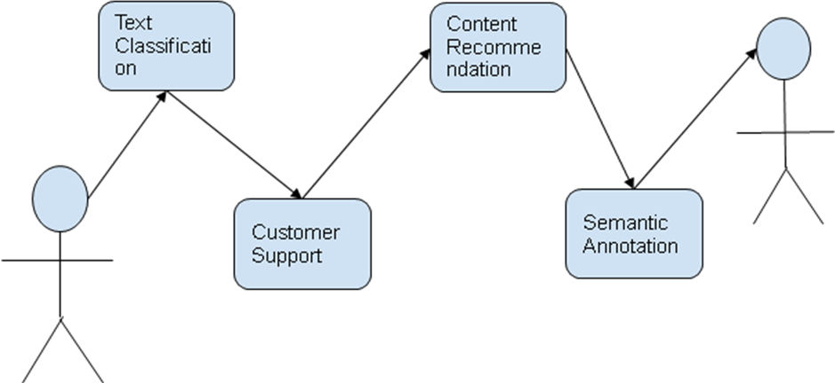

2.4 DFD Diagram:

Sentence Splitter
Tokenizer
Part of Speech Tagger
Gazetter
Semantic Tagger
NER
Input
Output

2.5 State Transition Diagram:

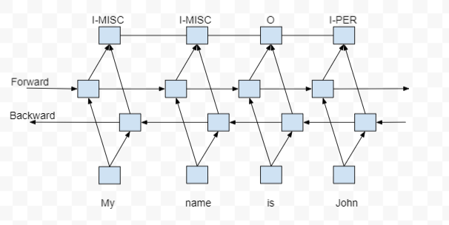

Chapter 03|IMPLEMENTATION

3.1 Date Set Used:
Link-
https://github.com/dice-group/FOX/tree/master/input/Wikiner
https://www.kaggle.com/abhinavwalia95/entity-annotated-corpus

3.2 Date Set Features
3.2.1 Types of Data Set: We have used two different datasets for two different models. First dataset is performed using LSTM model and Second Dataset is performed using Bert model.

3.2.2 Number of Attributes, fields, description of the data set: Dataset includes
Sentence, Word, POS(Parts of Speech) and Tag attributes. Dataset is about the important information from newsletter which is sort of paragraph and used to identify each word whether a word is a named entity or not and how we can extract information from it.

3.3 Design of Problem Statement
We have a data set which is tagged, annotated and built specifically to train the classifier to predict named entities such as name, location, etc. that talks about some important information from a newsletter. It has sentences on news and each word in the sentence has a tag. For example-Below mentioned figure contains the paragraph as input and output includes some important named entities like Google , Sergey Brin is organization and Larry Page is shown as Person and the United States of America is the location whereas cardinal defines the number.
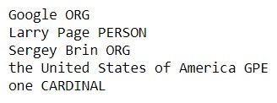

3.4 Algorithm / Pseudo code of the Project Problem
LSTM Model
Step-1 Import Modules.
Step-2 Load and Explore NER Dataset.
Step-3 Visualizing the sentence.
Step -4 Retrieve Sentences and Corresponding Tags.
Step-5 Define mapping between sentences and tags
Step-6 Padding Input Sentences and Creating Train/Test Splits.
Step-7 Build and Train the model.
Step -8 Evaluate named Entity Recognition.

Bert Model
Step-1 Load dataset.
Step-2 Set Data into trainingembeddings(includedpreprocessing ,setting of arguments, labels).
Step-3 Train model.
Step-4 Evaluate model performance.

3.5 Flow graph of the Project Problem
Using Spacy

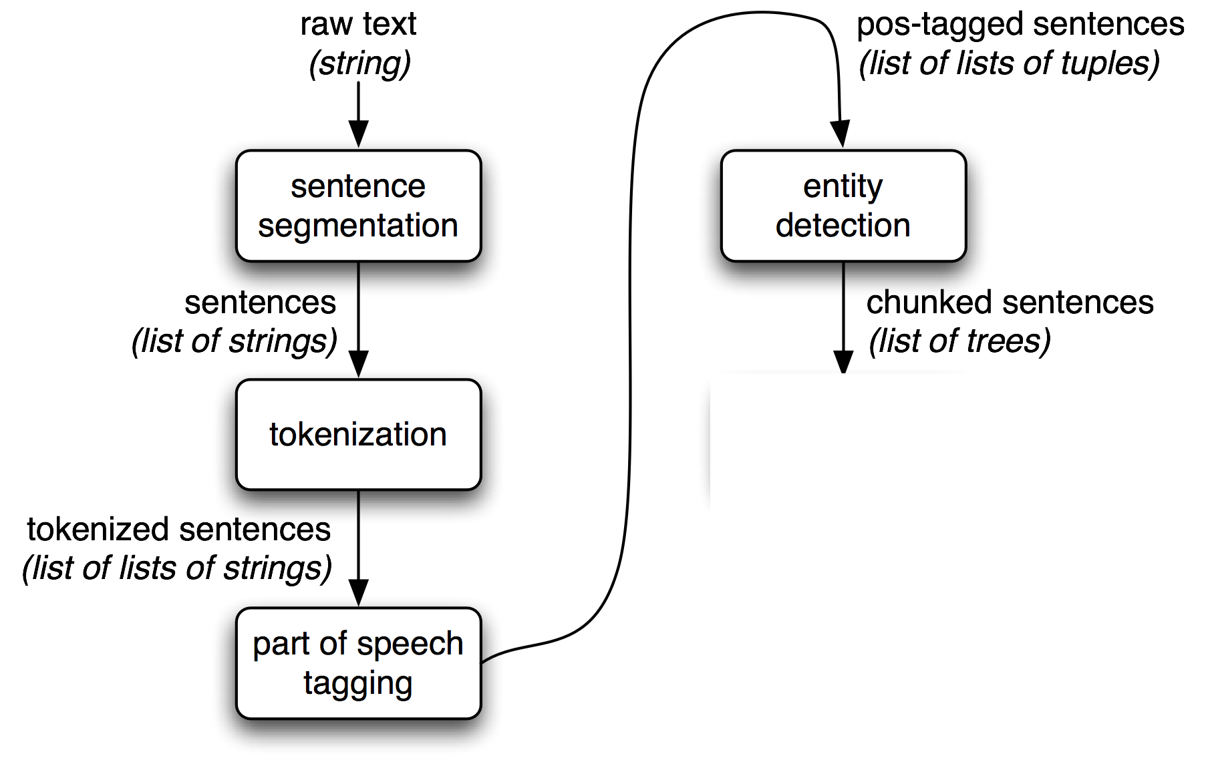

Using LSTM and Bert
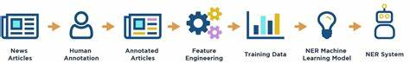

3.6 Screen shots of the various stages of the Project
LSTM Model
Importing Modules
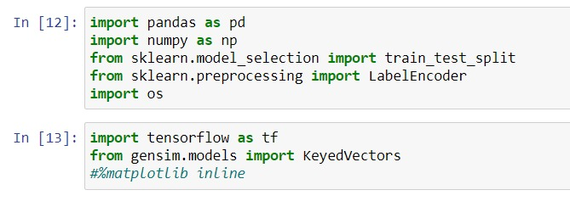
Load and Explore NER Dataset.
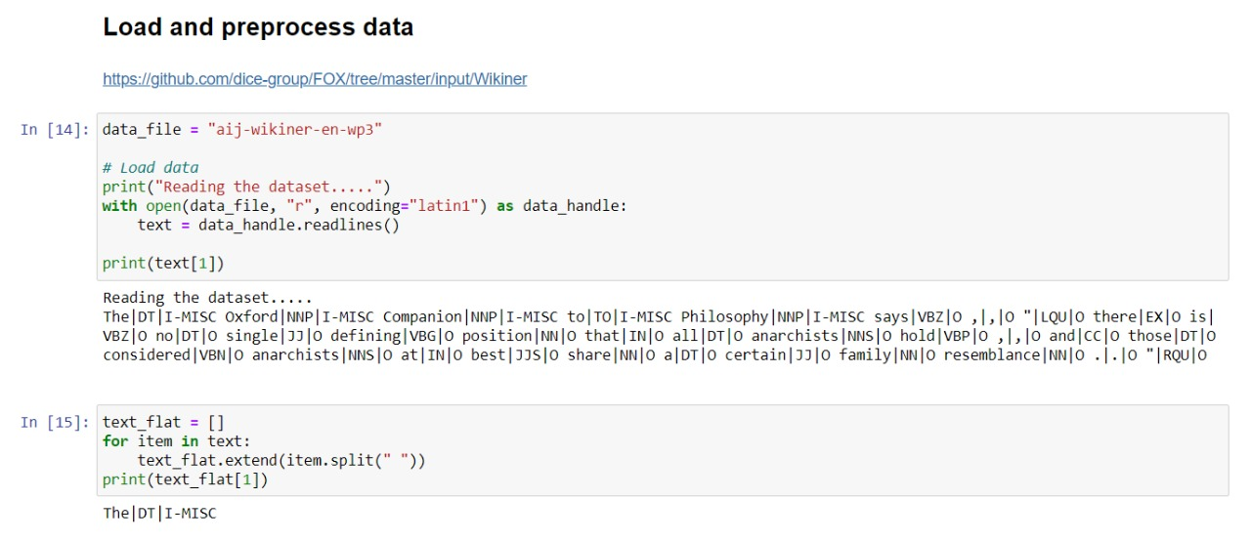

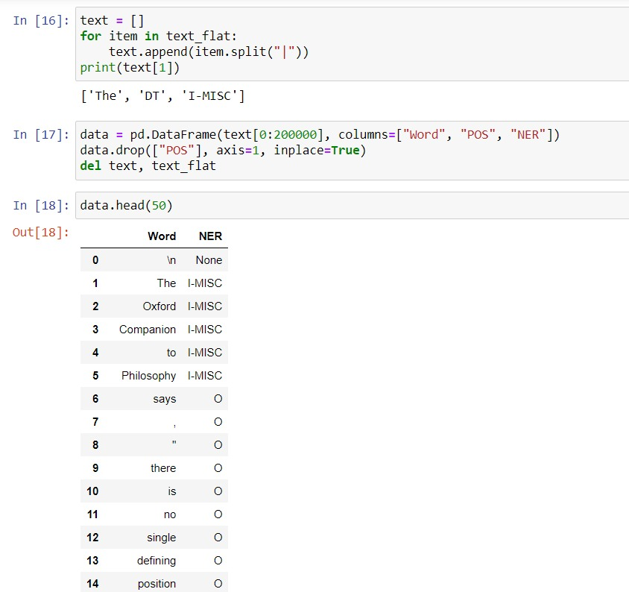

Retrieving words and Corresponding Tags.
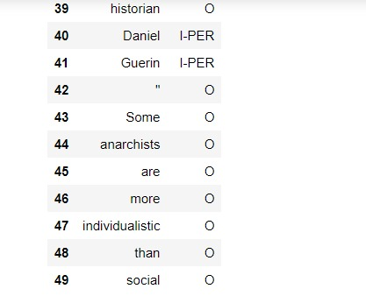

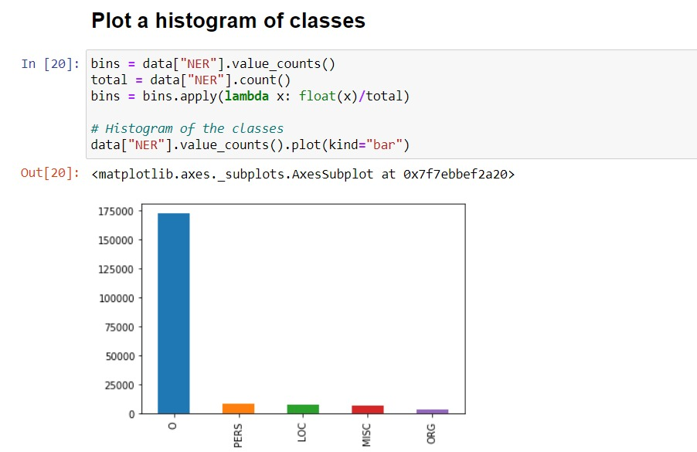

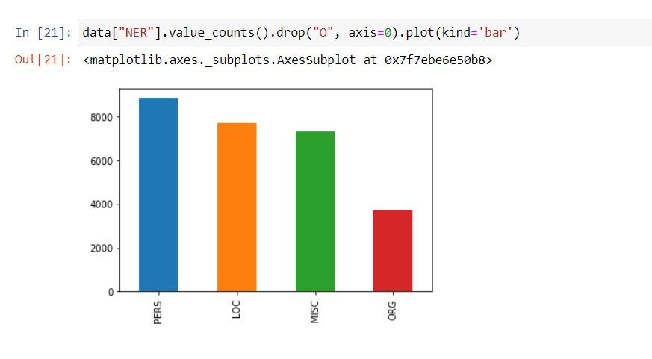

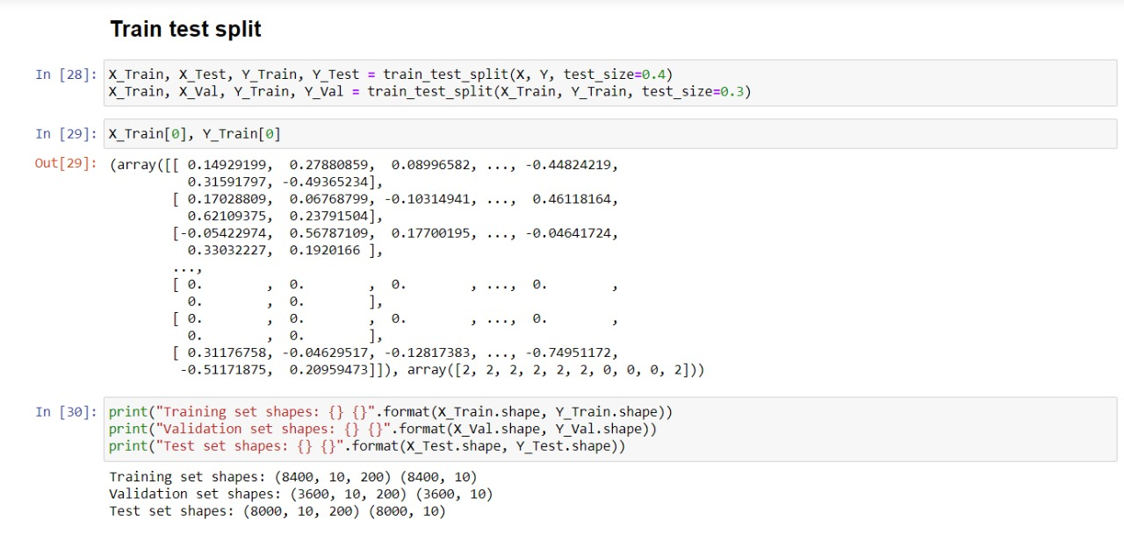

Final Output
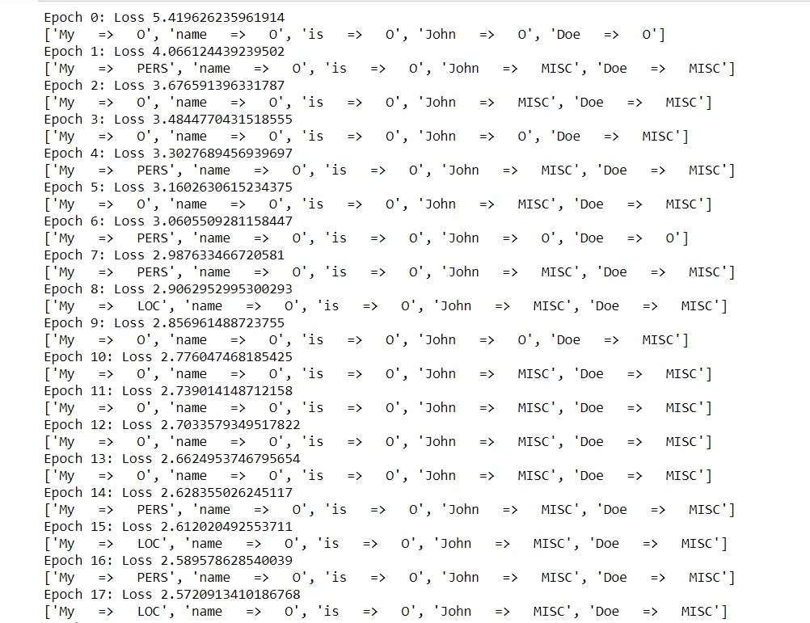
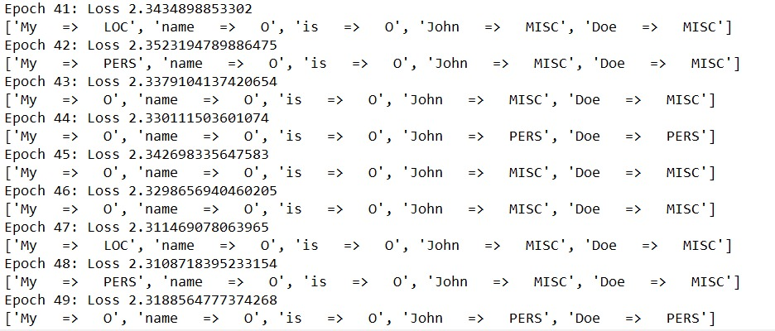

Bert Model
Load dataset
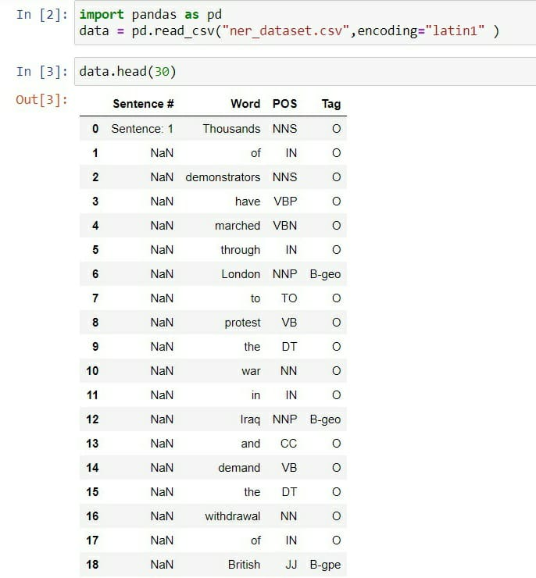

Trained Data
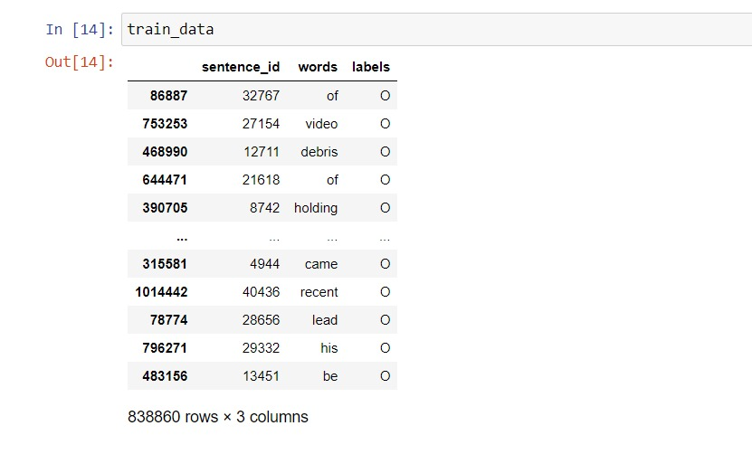
Result
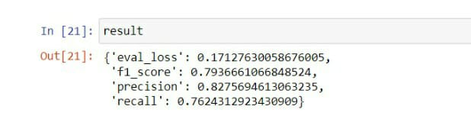

Chapter 04| RESULTS

  - Discussion on the Results Achieved
Comparing both the models BERT performed a little better than LSTM but no significant difference when the models are trained for the same amount of time. Three epochs of training the pretrained BERT took almost the same time as the five epochs of the LSTM model. BERT has better accuracy than LSTM,
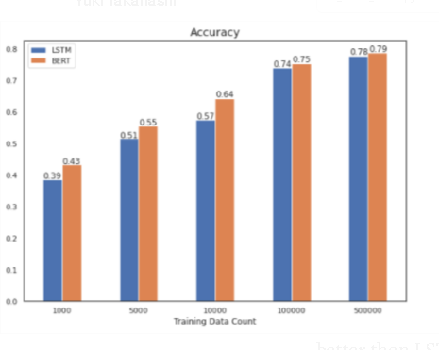

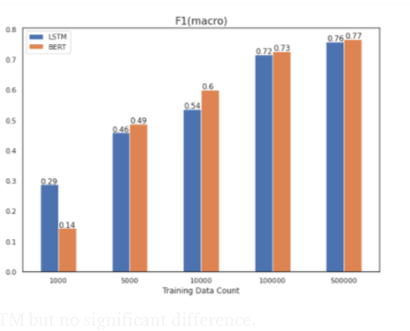

4.2 Applications of the Minor Project

NER has a lot of applications in the field of natural language processing and information extraction. Some of them are listed below:
Classifying content for news providers: A large ratio of online content is generated by the news on a daily basis and managing them correctly can be a challenging task for workers. NER can automatically scan full articles and help in identifying and retrieving major people, companies, and locations discussed in them. Thus articles are automatically categorized in defined hierarchies and the content is also more conveniently discovered.

Automatically Summarizing Resumes: We all have probably come across some tool that scan our resume and retrieve important information such as Name, Address, Qualification from them. The majority of such tools use the NER software which helps it to retrieve such information and also one of the challenging tasks faced by the HR Departments across companies is to evaluate a pile of resumes to shortlist candidates. Most of these resumes are very populated in detail, of which, most of the information is useless to the evaluator. Using the NER model, the useful information to the evaluator can be easily found from them which simplifies the effort required in short listing candidates among a ton of resumes.
Optimizing Search Engine Algorithms: While working on a search engine algorithm, it would be an computational task to search for an entire query across the millions of articles online, a better way is to just run a NER model on the articles once and store the entities related to them permanently. So, for a fast and effective search, the critical tags in the search query can be compared with the tags associated with the site articles.
Powering Recommendation systems: NER can be used in developing algorithms for recommender frameworks that make ideas dependent on our search history or our activity. This is done by extracting the entities related to the content in our history and comparing them with the label assigned to other unseen content. So, we frequently see the content of our interest.
Simplifying Customer Support: Noarmally, an organization gets a lot of customer complaints and feedback on a daily basis, and going through each one of them and perceiving the concerned parties is not an easy task. Using NER we can recognize relevant entities in these complaints and feedback such as Product specifications, or company branch area so that the feedback is classified accordingly and sent to the suitable department responsible for the identified product.

  - Limitations of the Minor Project
- Traditional NER techniques are inadequate to handle the unstructured big data.
- Supervised learning techniques require a lot of annotated data for training and that is a difficult task for large-scale datasets.
- Weakly supervised learning is effective as viable to supervised methods due to decreased manual effort. But still, the sparsity of data make these techniques useless.
- In this regard, reinforcement learning for IE can overcome the limitations of the above mentioned techniques.
- On the other hand, open nature of vocabulary, abbreviations and different languages and domains are major entity-specific challenges.
- Language related issue i.e. specific language , different languages or poor morphological influencing NER techniques.
- Data related issues like variation in text perspective and domain specific entities.

4.4 Future Work
One can make modifications to improve the solution by:
- Changing model parameters like the number of epochs, embedding dimensions, batch size, dropout rate and so on.
- Using larger dataset. Here we have used only 48909 sentences which are very few to build a good model for entity recognition problem.
- Using pre-trained word embeddings.
- Using character level embedding for LSTM.
- Fine tuning of the BERT model.
- Improve the vocabulary by adding the unknown tokens which appeared at test time by replacing the all uncommon word on which we trained the model. We have not done this for sec of simplicity.

References
- Ritter, A.; Clark, S.; Mausam; Etzioni., O. (2011). Named Entity Recognition in Tweets: An Experimental Study (PDF). Proc. Empirical Methods in Natural Language Processing.

- Ratinov, L., & Roth, D. (2009, June). Design challenges and misconceptions in named entity recognition. In Proceedings of the Thirteenth Conference on Computational Natural Language Learning (pp. 147–155). Association for Computational Linguistics.

- Derczynski, Leon and Diana Maynard, Giuseppe Rizzo, Marieke van Erp, Genevieve Gorrell, Raphael Troncy, Johann Petrak, and Kalian Botcheva (2014). “Analysis of named entity recognition and linking for tweets”. Information Processing and Management 51(2) : pages 32–49

- Nadeau, David; Sekine, Satoshi (2007). A survey of named entity recognition and classification (PDF). LingvisticaeInvestigationes.

- Poibeau, Thierry; Kosseim, Leila (2001). "Proper Name Extraction from Non-Journalistic Texts" (PDF). Language and Computers. 37 (1): 144–157.

